Average larval and pupal densities w/ SE from ponds. The last date is the last sampling date BEFORE moz started emerging.

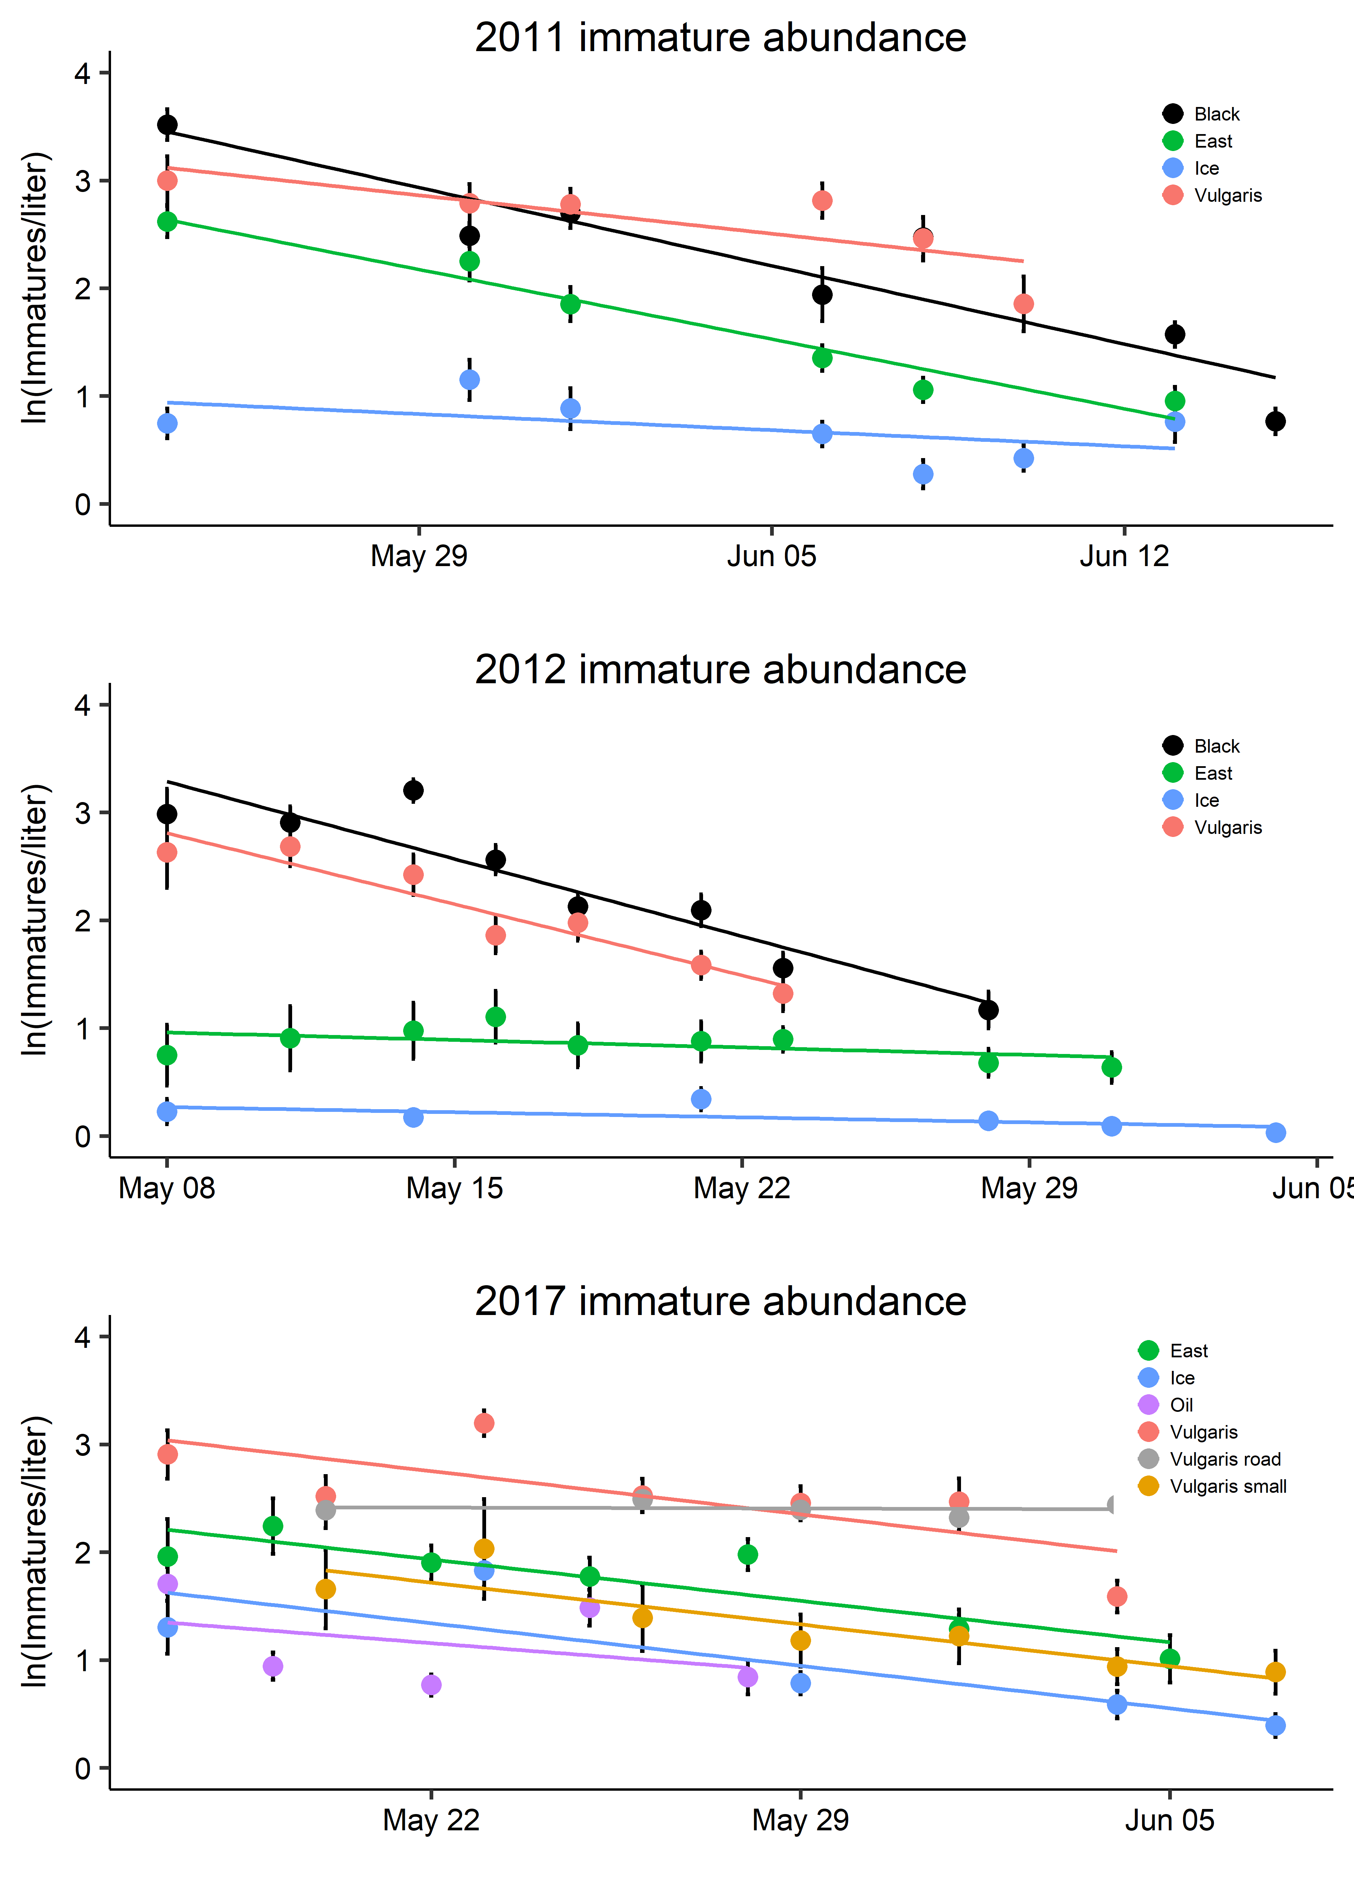

Linear regressions for each of the Years and ponds. The slope is interpretable as percapita mortality

**Slope seems right but intercept is weird…maybe because of date?

> pondsallyearssummary

Site Year intercept slope Original density (ln/liter)

1 Black 2011 1570.30524 -0.103641598 3.5180236

2 Black 2012 1588.43830 -0.102479469 2.9836598

3 East 2011 1397.79936 -0.092284987 2.6182067

4 East 2012 154.66845 -0.009937228 0.7492241

5 East 2017 953.20222 -0.054961199 1.9609632

6 Ice 2011 323.17366 -0.021314581 1.1506388

7 Ice 2011 323.17366 -0.021314581 0.7478135

8 Ice 2012 104.54357 -0.006741445 0.2260384

9 Ice 2017 977.52348 -0.056400606 1.3053358

10 JuncusTown 2017 479.70804 -0.027672627 0.8522946

11 Mozvalley 2017 1264.13665 -0.072880359 3.0907132

12 NoOil 2017 299.49199 -0.017146970 2.8111243

13 Oil 2017 660.54044 -0.038097029 1.7060548

14 SBS 2017 3635.25565 -0.209931418 2.7704842

15 SeahorseWetland 2017 -204.31941 0.011851605 1.0822507

16 ShotgunFairy 2017 681.55660 -0.039348039 0.8423351

17 Vulgaris road 2017 23.30961 -0.001207230 2.3904708

18 Vulgaris small 2017 962.89606 -0.055533663 1.6591847

19 Vulgaris 2011 774.56801 -0.051028602 2.9987850

20 Vulgaris 2012 1460.81232 -0.094259354 2.6292676

21 Vulgaris 2017 991.34025 -0.057117412 2.9071410

Pond Temps Across 3 years – very comporable

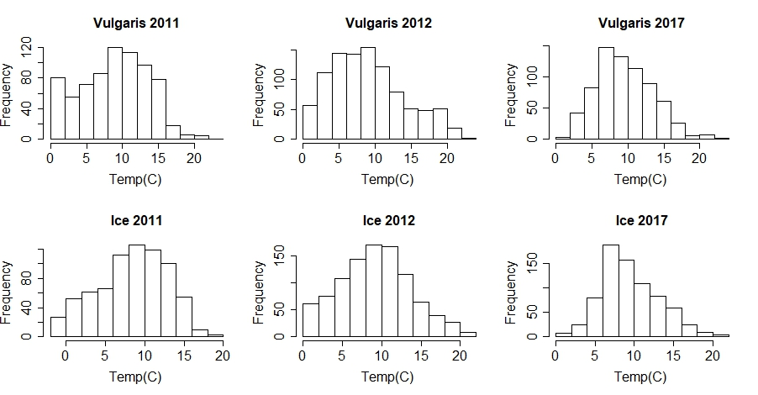

Average pond temps during immature development

Site Year N Temp sd se ci

1 Experiment 2017 448 7.993333 4.743873 0.2241269 0.4404733

2 Ice 2011 551 7.796733 4.571499 0.1947524 0.3825496

3 Ice 2012 678 8.330678 4.770590 0.1832134 0.3597348

4 Ice 2017 509 9.302733 3.942900 0.1747660 0.3433531

5 Oil 2017 299 9.668328 3.702942 0.2141467 0.4214314

6 Vulgaris 2011 503 7.849901 4.867859 0.2170471 0.4264326

7 Vulgaris 2012 174 6.308046 4.330273 0.3282771 0.6479440

8 Vulgaris 2017 413 8.743286 4.211573 0.2072380 0.4073757

9 VulgarisRoad 2017 437 7.789412 3.538727 0.1692802 0.3327068

10 Black 2011 599 9.182805 4.516087 0.1845223 0.3623905

11 Black 2012 534 8.131086 3.644324 0.1577053 0.3098002

12 East 2011 551 8.692377 4.428751 0.1886711 0.3706041

13 East 2012 558 5.744982 3.800104 0.1608712 0.3159884

Each point is a pond from 2011, 2012 or 2017. Per capita mortality calculated as -1*slope of line in 1st figure. Plotted against the initial density/liter (from first sampling event of year). Positive slope (significant) indicates that there is density dependent mortality.

|  |  |  |  |  |  |  |  |  |  |
| --- | --- | --- | --- | --- | --- | --- | --- | --- | --- |
| Ponds | Year | Percapita  mortality | Original density (ln/liter) | Beetle density (ln/liter) | Avg Water Temp | DOC | Pupae size (mg) | Adult mass  (mg) | Adult wing length |
| Black | 2011 | 0.103642 | 3.5180236 | 0.156764 |  |  |  |  |  |
| Black | 2012 | 0.102479 | 2.9836598 | 0.073361 |  |  |  |  |  |
| East | 2011 | 0.092285 | 2.6182067 | 0.122652 |  |  |  |  |  |
| East | 2012 | 0.009937 | 0.7492241 | 0.031379 |  |  |  |  |  |
| East | 2017 | 0.054961 | 1.9609632 | 0.10472 |  |  |  |  |  |
| Ice | 2011 | 0.021315 | 1.1506388 | 0.391959 |  |  |  |  |  |
| Ice | 2012 | 0.006741 | 0.2260384 | 0.268979 |  |  |  |  |  |
| Ice | 2017 | 0.056401 | 1.3053358 | 0.380261 |  |  |  |  |  |
| JuncusTown | 2017 | 0.027673 | 0.8522946 | 0 |  |  |  |  |  |
| Mozvalley | 2017 | 0.07288 | 3.0907132 | 0.159655 |  |  |  |  |  |
| NoOil | 2017 | 0.017147 | 2.8111243 | 0.135381 |  |  |  |  |  |
| Oil | 2017 | 0.038097 | 1.7060548 | 0.038403 |  |  |  |  |  |
| SBS | 2017 | 0.209931 | 2.7704842 | 0.089347 |  |  |  |  |  |
| Seahorse  Wetland | 2017 | -0.01185 | 1.0822507 | 0.191103 |  |  |  |  |  |
| ShotgunFairy | 2017 | 0.039348 | 0.8423351 | 0.030132 |  |  |  |  |  |
| Vulgaris road | 2017 | 0.001207 | 2.3904708 | 0.295648 |  |  |  |  |  |
| Vulgaris small | 2017 | 0.055534 | 1.6591847 | 0.167665 |  |  |  |  |  |
| Vulgaris | 2011 | 0.051029 | 2.998785 | 0.354727 |  |  |  |  |  |
| Vulgaris | 2012 | 0.094259 | 2.6292676 | 0.147094 |  |  |  |  |  |
| Vulgaris | 2017 | 0.057117 | 2.907141 | 0.206273 |  |  |  |  |  |

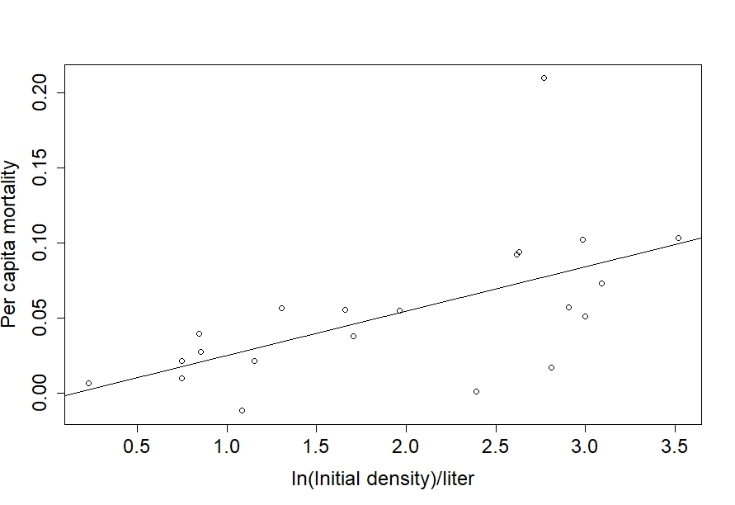

Call:

lm(formula = (slope * -1) ~ Larvaepupaeliter, data = pondsallyearssummary)

Residuals:

Min 1Q Median 3Q Max

-0.065139 -0.014156 0.003504 0.018606 0.132357

Coefficients:

Estimate Std. Error t value Pr(>|t|)

(Intercept) -0.004285 0.020011 -0.214 0.83272

Larvaepupaeliter 0.029547 0.009186 3.216 0.00454 **

---

Signif. codes: 0 ‘***’ 0.001 ‘**’ 0.01 ‘*’ 0.05 ‘.’ 0.1 ‘ ’ 1

Residual standard error: 0.04067 on 19 degrees of freedom

Multiple R-squared: 0.3525, Adjusted R-squared: 0.3185

F-statistic: 10.35 on 1 and 19 DF, p-value: 0.004543

Beetle densities average over the time of immature development. Beetle densities don’t seem to affect per capita mortality.

